IRELAND HISTORICAL SOCIETY
IRELAND, INDIANA
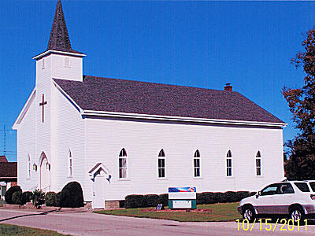
PUBLIC IS INVITED TO STOP IN

The Ireland Historical Society, on the corner of James & Walnut, will have an open house on Saturday, March 16 from 11am to 4pm, featuring Irish Nachos and 17 yrs of collected history.
Also, open house from 10 till everyone leaves on Sunday the 17th. Again, featuring the above. An added one-time happening is the public celebration featuring the Ireland Spuds 1963 team’s 50th anniversary of winning the sectional and regional. This will be held upstairs in the Ireland Historical Chapel in the society’s building. Nachos will again be available in the basement.

